**Team Name:** Social Circle

**Grouping Categories for Users:**

1. Major
2. Year
3. Clubs
4. Sports
5. Gender
6. Residence
7. Interests
8. Job

**User Stories:**

* As a User, I want to be able to see my friends in my res hall.
* As a User, I want to be able to see my friends in my organization.
* As a User, I want to be able to see my friends from work.
* As a User I want the ability to input my basic information and interests.
* As a User, I want to be able to schedule meetings with other users.
* As a User, I want to be able to see how many levels of separation there are between myself and any given user.
* As a User, I want to be able to see my network at a certain limit on levels of separation.
* As a User, I want to be able to search for people with similar interests.
* As a User, I want to see my network sorted by category.
* As a User, I want to be able to see my search results sorted by depth level of friends.
* User types a name into a textbox and presses a button labeled "Search" next to the textbox. Then a list of people who share that name appears in an increasing depth.
* User clicks a link with a group label and the group members' names appear on the screen in increasing depth order.
* As a User, I want to be able to delete my account.
* As an Anonymous User, I want to be able to create an Account.
* As a user, I would like the GUI to be similar to Google, where I simply have a main search screen and fill out variously desired filter options. Then a list of sorted results will be returned on a new screen.
* As a user I would want to perform filtered searches such as “finding all CS majors who play tennis of no more than a depth level of three.”
* As a user, I would like to filter search through my list of already existing friends.

**Screen Reviews:**

**Login Screen:**

The login screen will be a basic looking login screen with the normal login and signup options. This will be the first screen users see when visiting the site, preventing any other user activity until they login or signup. After a user is logged in there will be a logout option in the top right corner of the screen. They will also have links to the three other main pages of the site in the top left of the screen: Search, Friends, and Meetings. Friends will simply be a list of a user’s current friends and Meetings will simply be a list of a user’s meetings in order from most current, to furthest away.

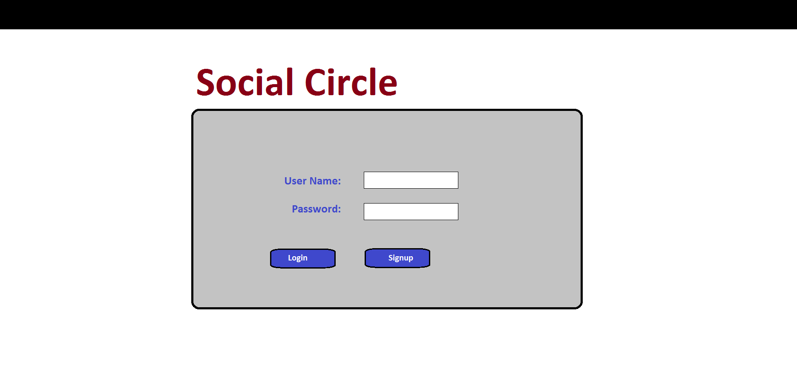----------------------------------------------------------------------------------------------------------------------------

**Search Screen:**

The search screen will be composed of user specified filtering criteria and a search button. The user can add as many search criteria as they desire by simply clicking the “add Search Filter” option from a drop down menu to specify the “type” of filter they wish to add (i.e. major, sport, club). Then they can select the “value” for that type through another drop down menu. (i.e. CS, Tennis, Drama Club – except for name where you must manually enter the user’s name). A user can remove any of their search criteria simply by clicking the red “X” to the left of any of the filters.

